Service NSW 17 November 2021

To Whom is May Concern,
This is to state that the Scout Association of Australia, NSW Branch is incorporated under The Scout Association of Australia (NSW) Incorporation 1928, Act No. 26, 1928 as amended by Act No. 45, 1968 and Act No. 148, 1986.
The A.B.N. of the Association is 42 460 434 054. The Association is a charitable institution with full tax concessions.
We authorise the transfer of registration of the vessel NAME, Boatcode, HIN CERTIFICATE NUMBER GOES HERE, Registration Number REGISTRATION NUMBER GOES HERE, into the name of the Association.
We authorise, PERSON MAKING THE APPLICATION, motor vehicle Driver’s Licence number: MV LICENCE NUMBER FOR PERSON APPLYING, to make the registration application on behalf of the Association.
We request that a new customer number be created for this Scout Group with the following details:
The Scout Association of Australia (NSW Branch)
_________ Scout Group

The location of the vessel is at:
WHERE THE VESSEL IS KEPT

Thank you for your assistance with this matter.
Yours sincerely,

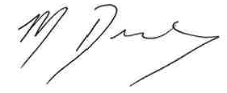

Melanie Dimmock
Administration Officer
Scouts Australia, NSW

