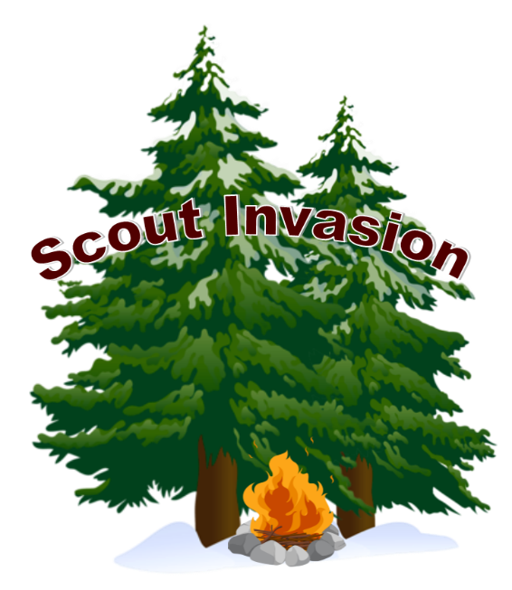

Scout Invasion Team Entry Form
Scout Invasion will be held on 3rd - 5th of June 2022.
Teams must consist of 4-7 members and should be of mixed age (mixed gender teams must have at least 2 of each gender)

Unit(s) of participants:______________________________________
Team name:______________________________________________
Name | Age | Gender

Adult Helper/Leader(s) (if possible):___________________________ Please email this form filled out to scoutinvasion@outlook.com by the 27th of May 2022.

